4.1 Introduction
This chapter presents the implementation of the Plant Disease Classifier system, which includes both the mobile application developed using Android Studio and the web application created with HTML, CSS, and JavaScript. The purpose of this chapter is to demonstrate how the designed system was transformed into a working software solution, explain its core functionalities, and show the results obtained during testing.
The mobile application enables users—such as farmers, students, and agricultural experts—to capture or upload leaf images directly from their Android devices. These images are processed by the trained machine learning model to identify plant diseases quickly and accurately. The interface is designed to be simple, responsive, and user-friendly.
In addition to the mobile app, a web-based interface has been developed to provide users with an alternative platform for accessing the classifier. The web application allows image upload through a browser and displays disease predictions in real time. This enhances accessibility by supporting users who prefer desktop or laptop usage.

4.2 Proposed System

The proposed system is an intelligent Plant Disease Classifier that automatically detects plant diseases from leaf images using a trained machine learning model. It provides fast, accurate, and accessible disease diagnosis through two platforms: a mobile app and a web app.
The mobile application, built in Android Studio, allows users to capture or upload leaf images and instantly receive disease predictions, making it suitable for real-time field use.
The web application, developed using HTML, CSS, and JavaScript, enables users to upload images through a browser and get quick predictions, offering convenience for desktop and laptop users.

4.3 Mobile app Screenshots:

4.3.1 Home Screen
These screens provide the main features of the app. The user can choose to upload an image, capture a photo, or browse previous predictions. The design is simple to ensure easy navigation.
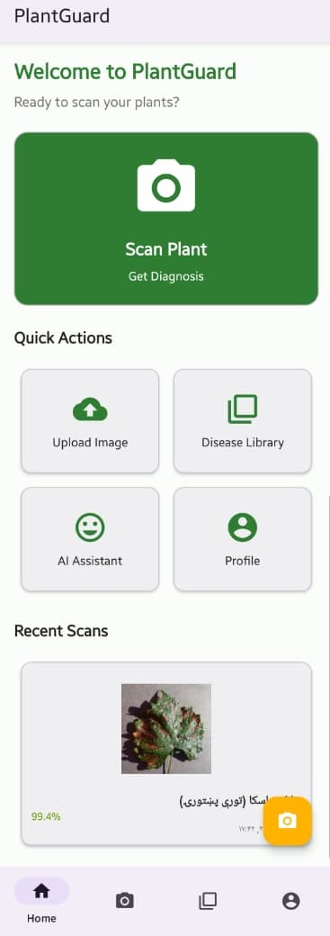
Figure4.3.1: Home screen

4.3.2 Image Upload / Capture Screen
These screens allow the user to select an image from the gallery or take a photo using the camera. Selected images are previewed before prediction. The system ensures the user chooses a clear leaf image for accurate classification
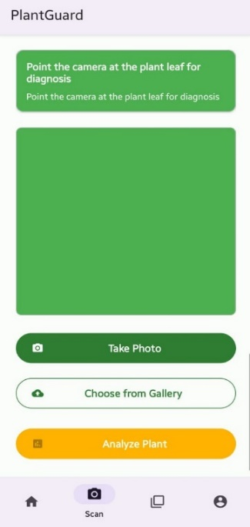
Figure4.3.2 :Image Upload / Capture Screen

4.3.3 Disease Library
This page is Disease Library allows to search and browse detailed information on various plant diseases and conditions. Identify problems, learn about causes and symptoms, and discover the right treatments to keep your plants thriving.

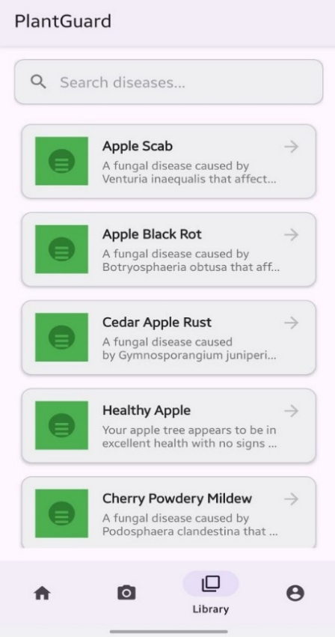
Figure4.3.3 : Disease Library

4.3.4 Disease Details Screen
This section shows detailed information about the identified disease, including causes, symptoms, environmental factors, and recommended solutions. This helps users understand the disease more deeply.
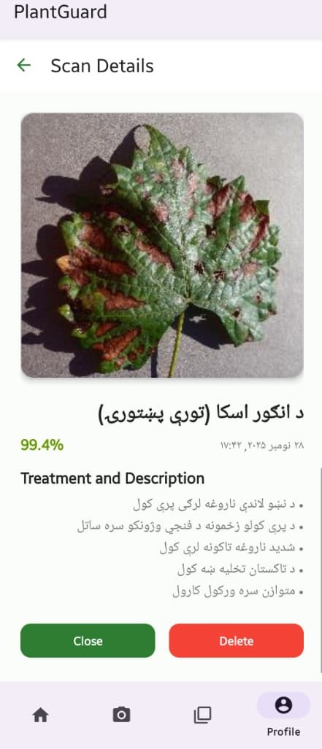
Figure4.3.4: Disease Details Screen

4.3.5 My Profile
The Profile section is the personal command center and digital greenhouse within the Plant Guard app. It serves as a customized space where users manage their identity, their plant collection, and their overall interaction with the application.
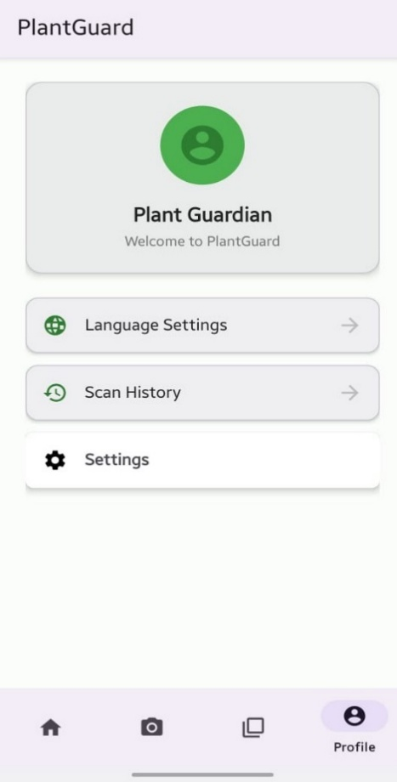
Figure4.3.5: My Profile

4.3.6 App Setting
In App Setting section in my app's control center. Here, I can personalize notifications, access help and privacy information, and share the app with others. It allows you to manage my support options and review app details. Essentially, it puts all the configuration and utility tools in one convenient place.
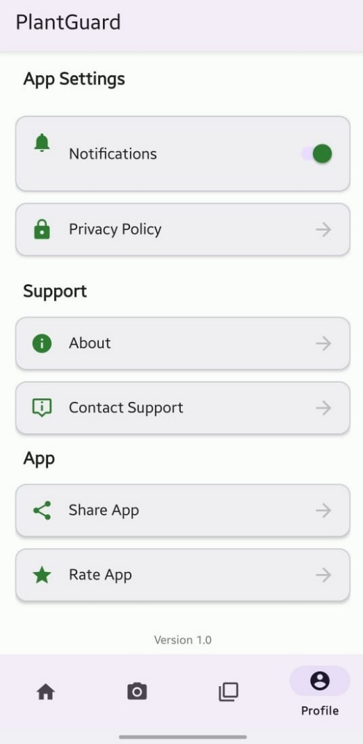
Figure4.3.6: App Setting

4.3.7 Language Selection
This page allows to manage the language of the Plant Guard app. You can see the currently selected language and choose from a list of available options to use the app in your preferred language, such as English, Dari, or Pashto. This ensures a personalized and accessible experience for all users.
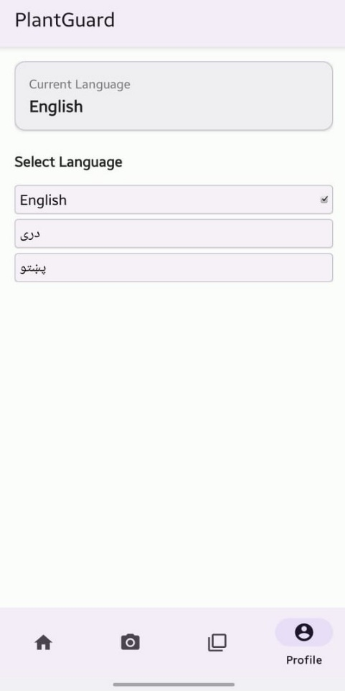

Figure4.3.7: Language Selection

4.3.8 AI Plant Assistant
This is AI Assistant provides instant help—from identifying plant diseases from your descriptions to offering detailed care tips and treatment solutions. Just type your question and get expert guidance to keep your plants healthy.

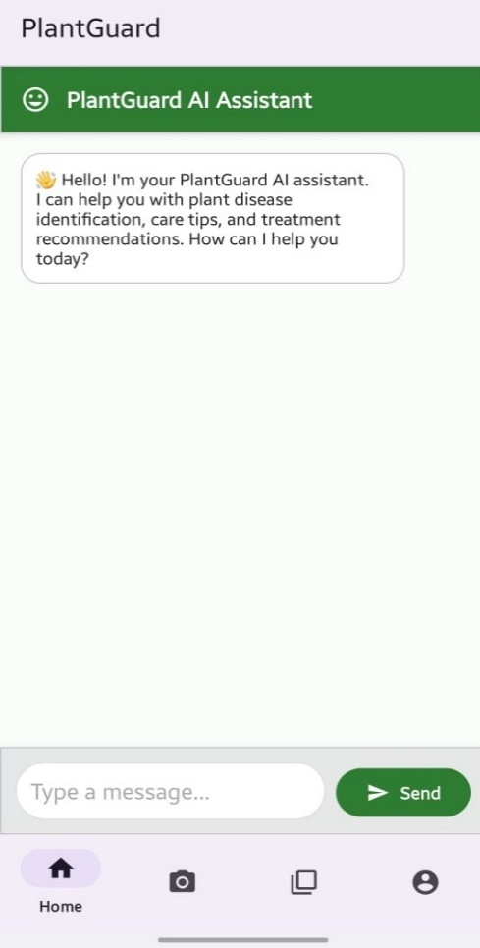
Figure4.3.8: AI Plant Assistant

4.4 Web App Screenshots:

4.4.1 Home Page
The Home Page of the web application acts as the main dashboard, providing users with an easy and clean interface. It includes an image upload area for starting new scans, a sidebar menu for quick navigation, and statistic cards showing total scans, plants in the garden, average confidence score, and the most detected disease. The page also displays recent scan history with images, disease names, and confidence levels. Overall, the Home Page gives users quick access to important features and a clear overview of their activity.
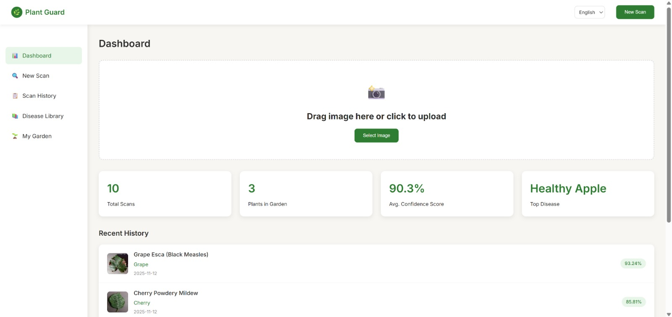
Figure4.4.1: Home Page

4.4.2 New Scan / Upload Page
The New Scan page allows users to upload leaf images for disease detection by either dragging and dropping or selecting a file from their device. It supports JPEG, PNG, and GIF formats up to 10MB. Tips for best results, such as good lighting and focusing on affected areas, are provided to improve prediction accuracy. The page ensures a simple, intuitive, and efficient way for users to submit images and receive disease predictions quickly.
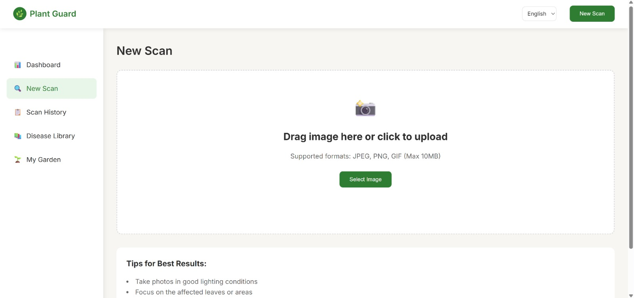

Figure4.4.2: New Scan / Upload Page

4.4.3 Scan History Page
The Scan History page displays a record of all previously scanned leaf images along with their corresponding disease predictions. Each entry includes the plant type, the predicted disease, the date and time of the scan, and the confidence percentage of the prediction. Users can quickly review past results, track plant health over time, and delete individual or all scan results using the provided options.
This page helps users maintain an organized history of their plant disease scans, allowing them to monitor patterns and make informed decisions for better plant care. It is designed with a clean, intuitive layout that makes navigation and review simple and efficient.
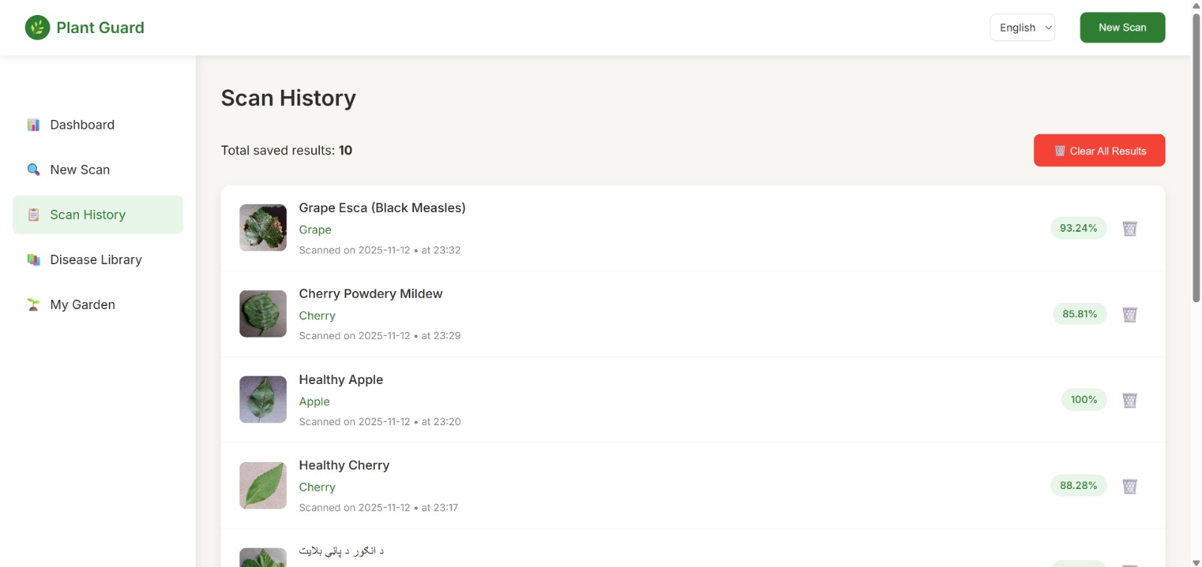

Figure4.4.3: Scan History Page

4.4.4 Disease Library Page
The Disease Library page provides a reference of all plant diseases included in the system. It lists the disease name, affected plant type, and details about symptoms, causes, and preventive measures. This page helps users understand detected diseases, learn more about plant health, and make informed decisions, all through a clean and easy-to-navigate interface.
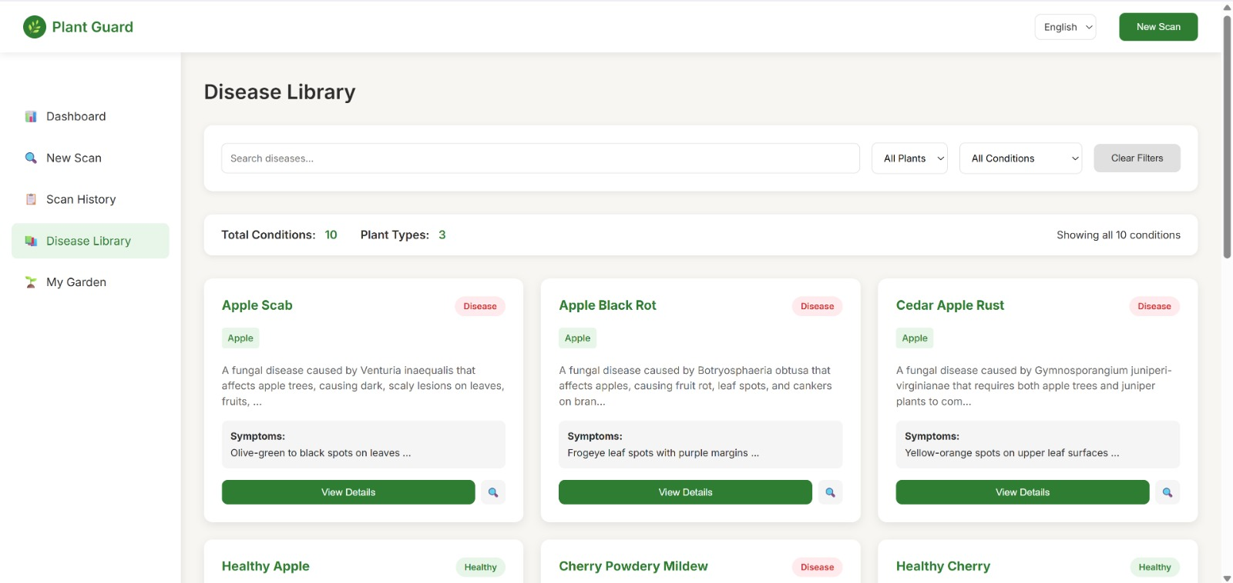

Figure4.4.4: Disease Library Page

4.5 Summary
In this chapter, the implementation of the Plant Disease Classifier system was presented, including both the mobile application developed using Android Studio and the web application built with HTML, CSS, and JavaScript. The system uses a trained machine learning model to detect plant diseases from leaf images, providing fast and accurate predictions for users.
The mobile app enables real-time image capturing and disease identification in the field, while the web app offers a convenient browser-based platform for desktop users. The chapter also highlighted how the proposed system overcomes the limitations of traditional manual disease detection by offering an automated, reliable, and user-friendly solution. Overall, the system successfully integrates machine learning with mobile and web technologies to support effective plant disease diagnosis.

